**Creating Microservices for account and loan**

**AccountController.java:**

package com.cognizant.account;

import org.springframework.web.bind.annotation.GetMapping;

import org.springframework.web.bind.annotation.PathVariable;

import org.springframework.web.bind.annotation.RestController;

import java.util.HashMap;

import java.util.Map;

@RestController

public class AccountController {

@GetMapping("/accounts/{number}")

public Map<String, Object> getAccount(@PathVariable String number) {

Map<String, Object> account = new HashMap<>();

account.put("number", number);

account.put("type", "savings");

account.put("balance", 234343);

return account;

}

}

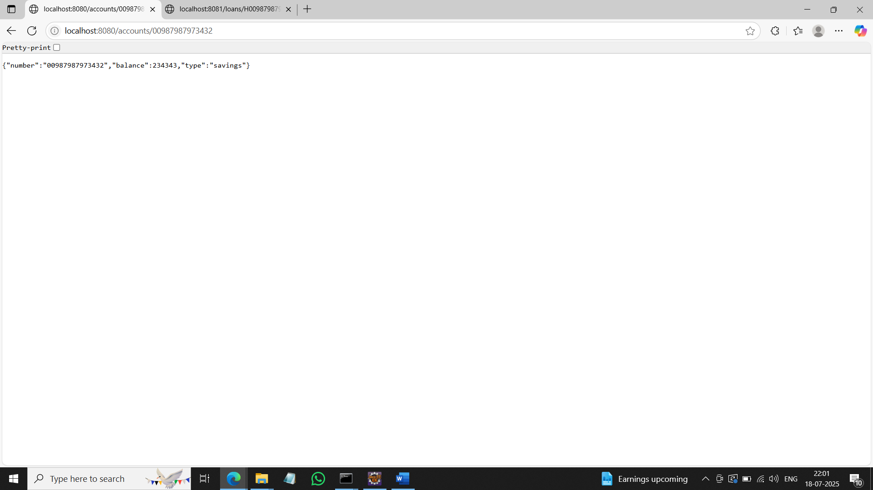

**LoanController.java:**

package com.cognizant.loan;

import org.springframework.web.bind.annotation.GetMapping;

import org.springframework.web.bind.annotation.PathVariable;

import org.springframework.web.bind.annotation.RestController;

import java.util.HashMap;

import java.util.Map;

@RestController

public class LoanController {

@GetMapping("/loans/{number}")

public Map<String, Object> getLoan(@PathVariable String number) {

Map<String, Object> loan = new HashMap<>();

loan.put("number", number);

loan.put("type", "car");

loan.put("loan", 400000);

loan.put("emi", 3258);

loan.put("tenure", 18);

return loan;

}

}

**Create Eureka Discovery Server and register microservices**

**Create and Launch Eureka Discovery Server:**

package com.cognizant.eureka_discovery_server;

import org.springframework.boot.SpringApplication;

import org.springframework.boot.autoconfigure.SpringBootApplication;

import org.springframework.cloud.netflix.eureka.server.EnableEurekaServer;

@SpringBootApplication

@EnableEurekaServer

public class EurekaDiscoveryServerApplication {

public static void main(String[] args) {

SpringApplication.*run*(EurekaDiscoveryServerApplication.class, args);

}

}

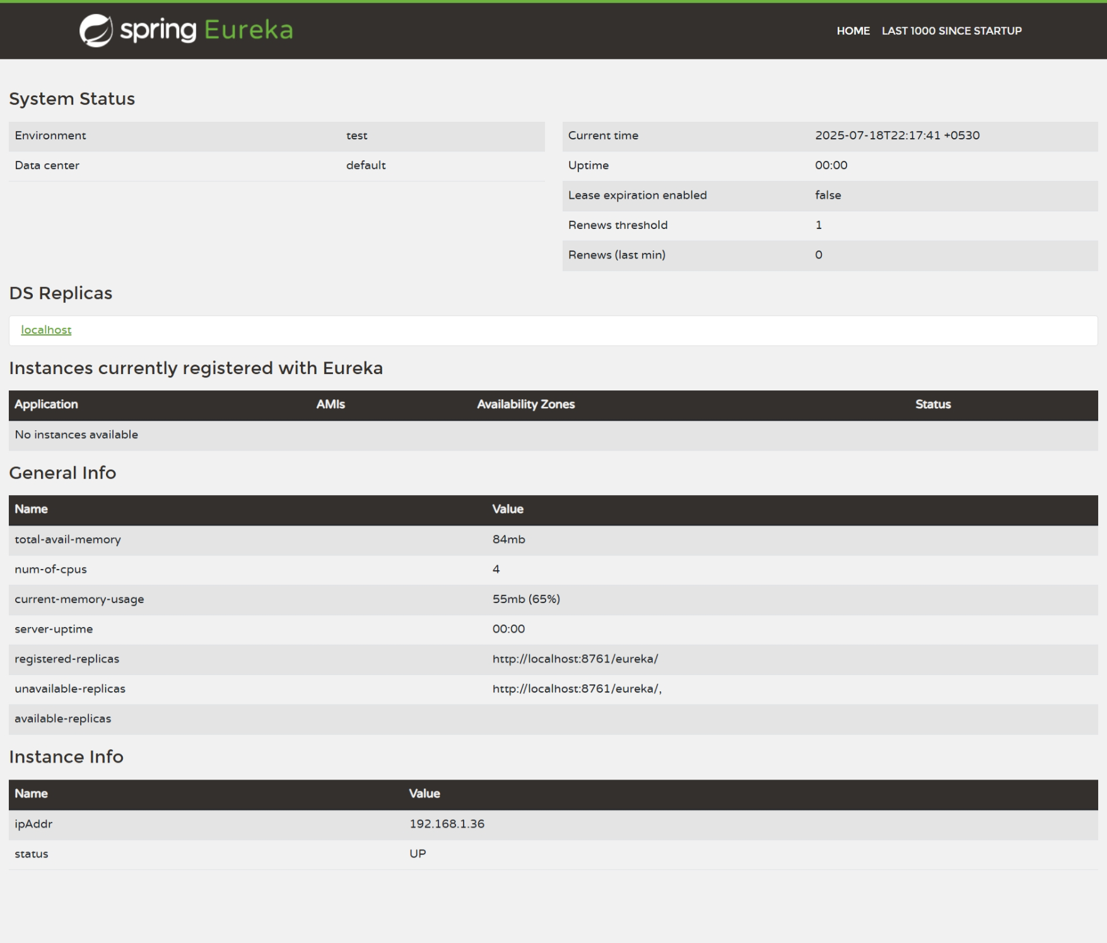

**Register Account REST API to eureka discovery:**

**AccountApplication.java:**

package com.cognizant.account;

import org.springframework.boot.SpringApplication;

import org.springframework.boot.autoconfigure.SpringBootApplication;

import org.springframework.cloud.client.discovery.EnableDiscoveryClient;

@SpringBootApplication

@EnableDiscoveryClient

public class AccountApplication {

public static void main(String[] args) {

SpringApplication.*run*(AccountApplication.class, args);

}

}

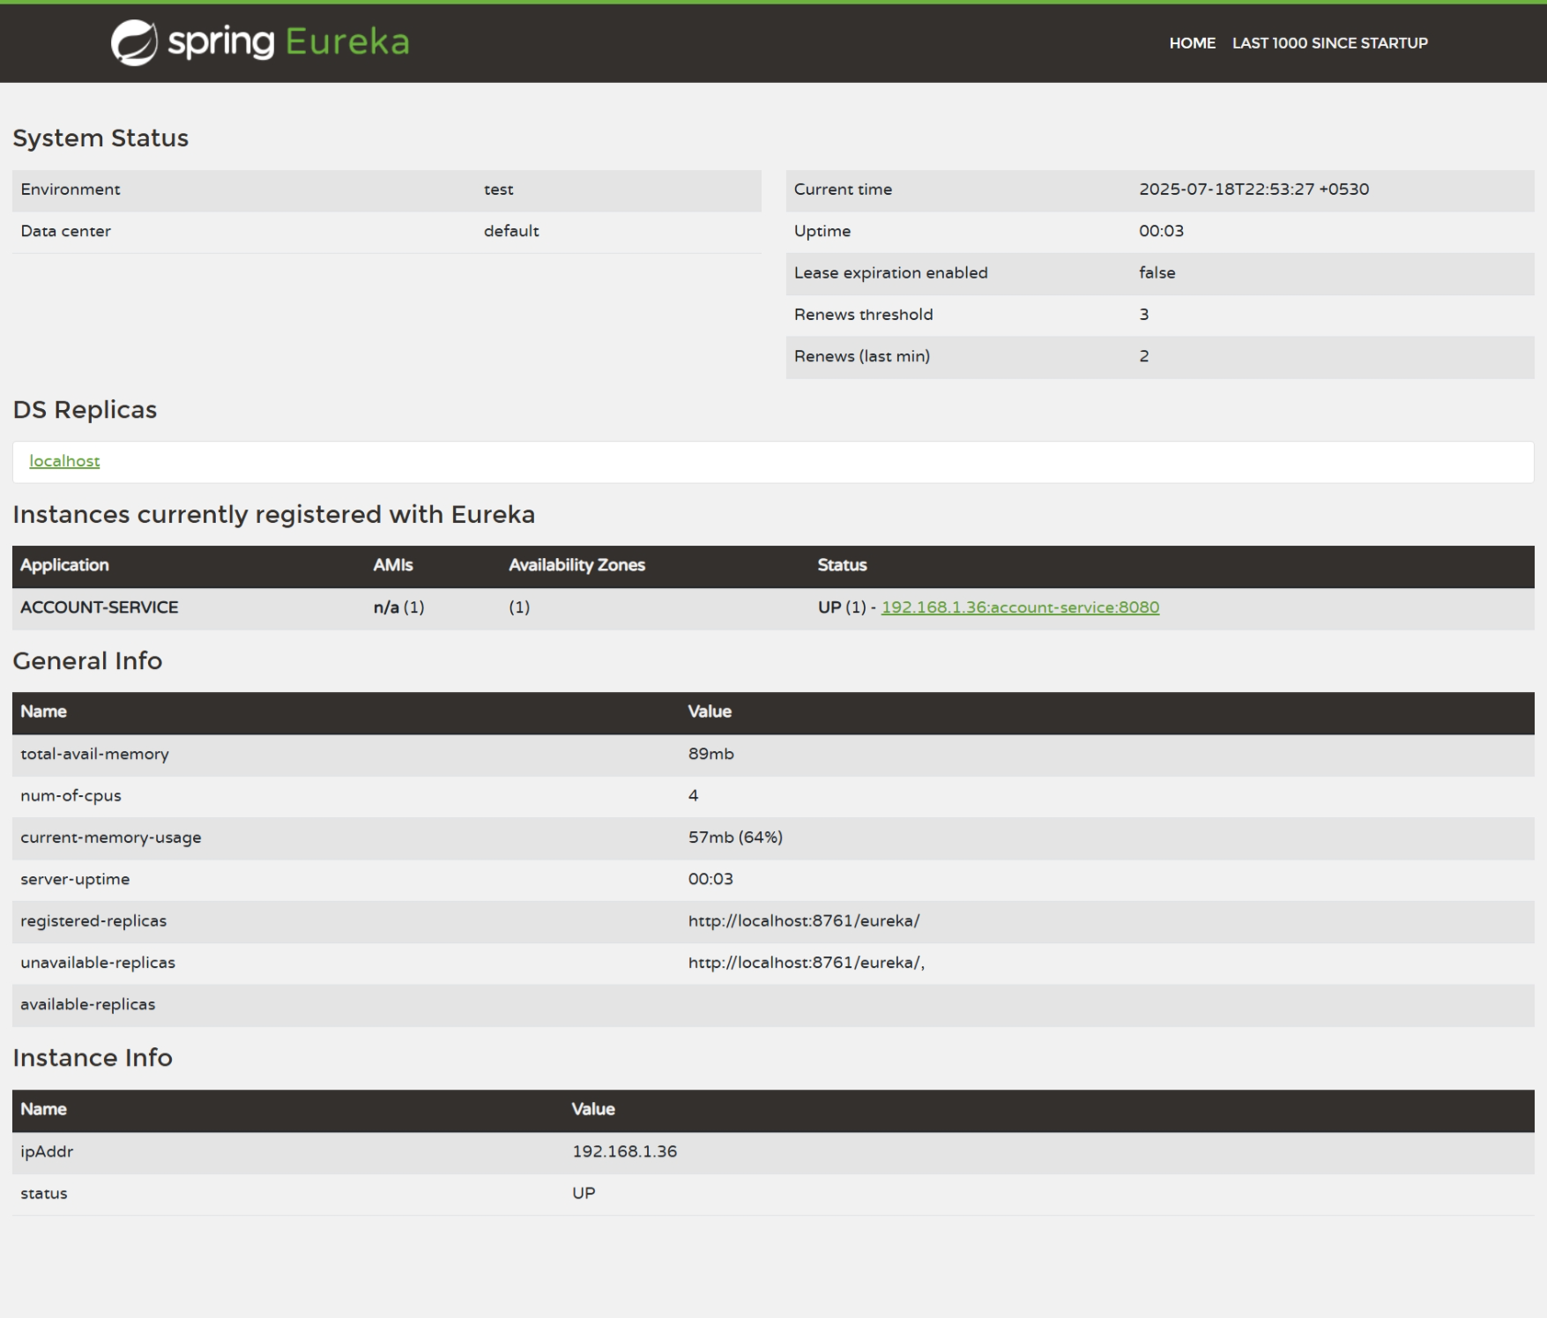

**LoanApplication.java:**

package com.cognizant.loan;

import org.springframework.boot.SpringApplication;

import org.springframework.boot.autoconfigure.SpringBootApplication;

import org.springframework.cloud.client.discovery.EnableDiscoveryClient;

@SpringBootApplication

@EnableDiscoveryClient

public class LoanApplication {

public static void main(String[] args) {

SpringApplication.*run*(LoanApplication.class, args);

}

}

